CaseManagement_Copying Case_Instance32_26-Jul-2018_08-24-37_AM_CopycaseVerifyCustomerName.png

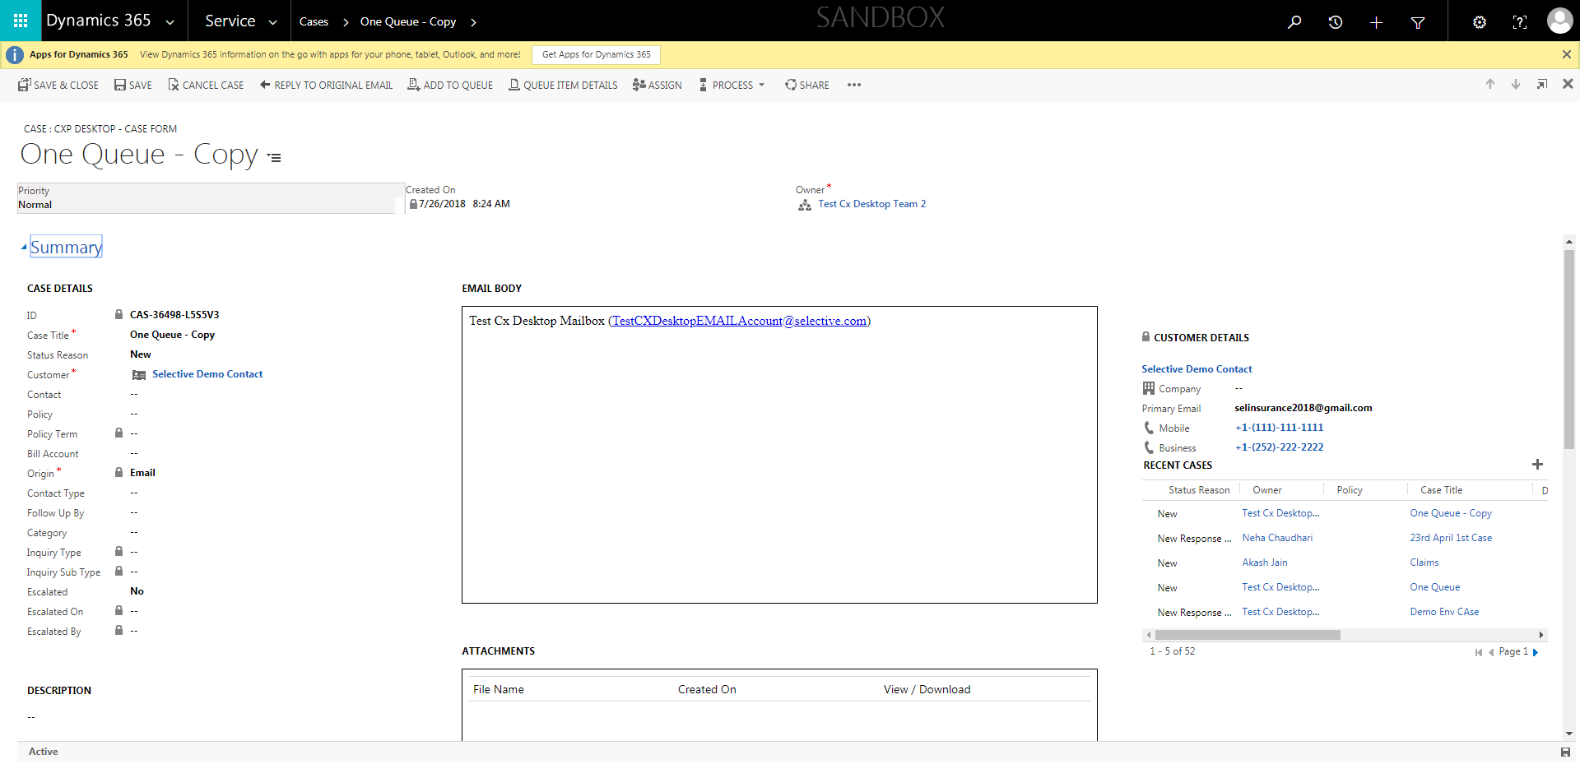

CaseManagement_Copying Case_Instance32_26-Jul-2018_08-24-39_AM_CopycaseVerifyPriority.png



CaseManagement_Copying Case_Instance32_26-Jul-2018_08-24-40_AM_CopycaseVerifyOrigin.png

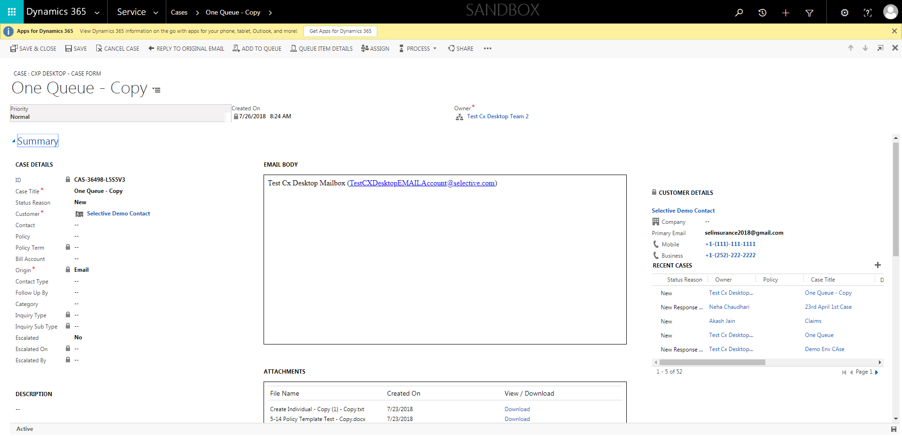

CaseManagement_Copying Case_Instance32_26-Jul-2018_08-22-46_AM_SingleSignOn.png

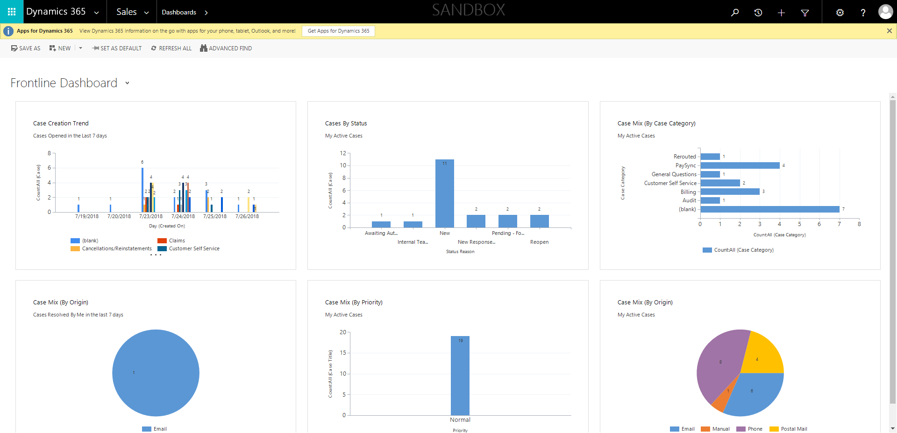

CaseManagement_Copying Case_Instance32_26-Jul-2018_08-22-25_AM_MouseClickActiononStaleElement.png

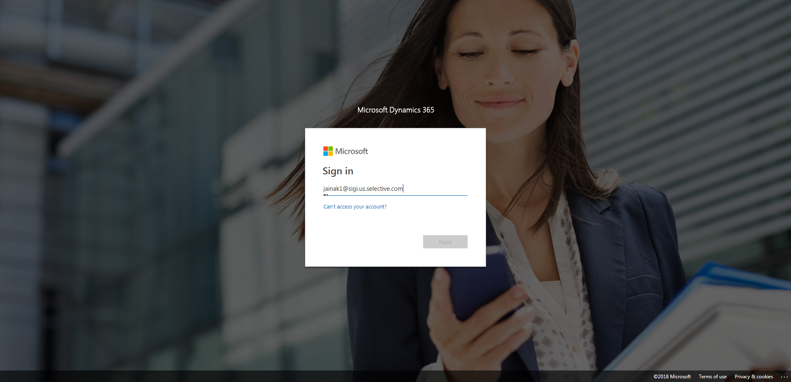

CaseManagement_Copying Case_Instance32_26-Jul-2018_08-24-38_AM_CopycaseVerifyTitle.png



CaseManagement_Copying Case_Instance32_26-Jul-2018_08-24-39_AM_CopycaseVerifyStatusReason.png



CaseManagement_Copying Case_Instance32_26-Jul-2018_08-22-24_AM_EnterTextAction.png

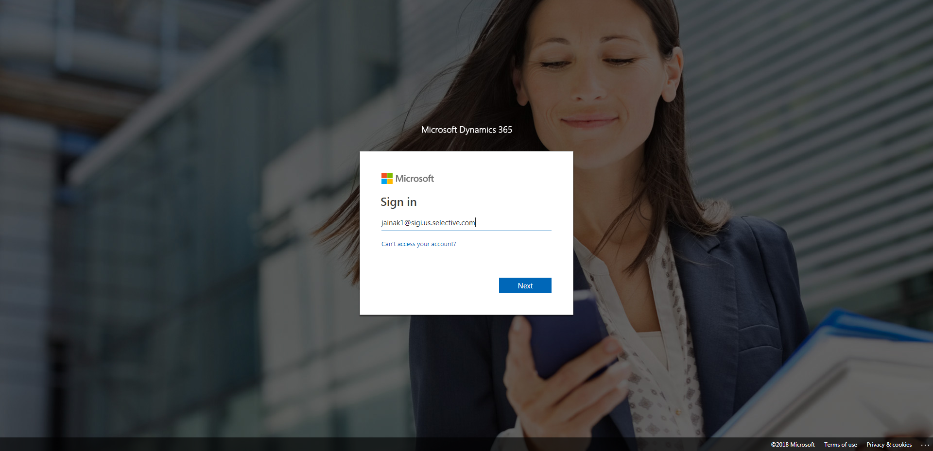

CaseManagement_Copying Case_Instance32_26-Jul-2018_08-24-34_AM_ValidatingCaseentitynavigation.png

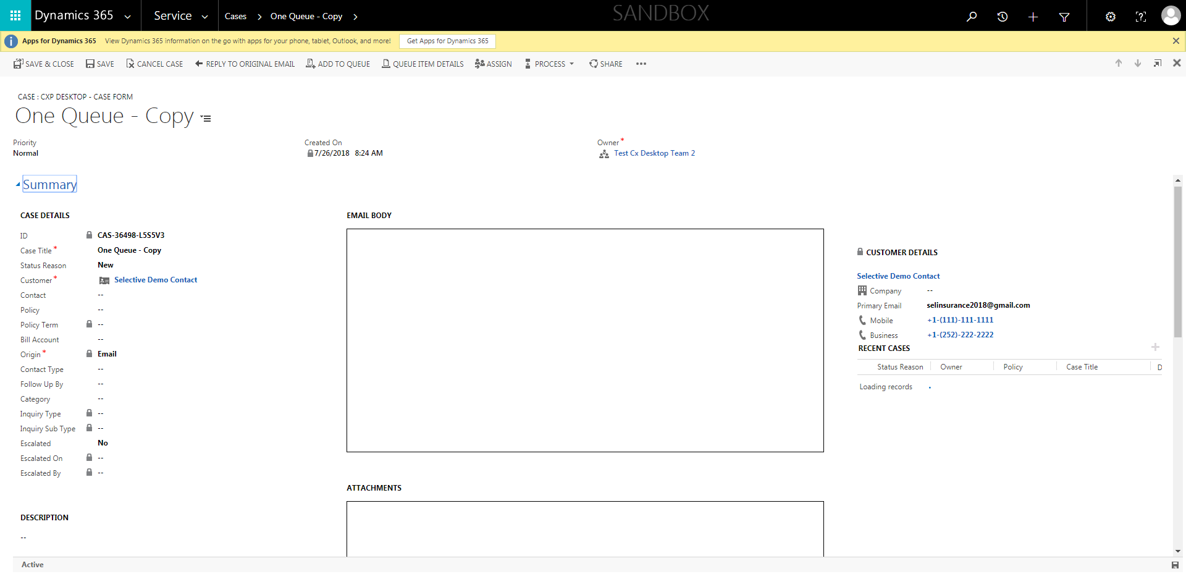

CaseManagement_Copying Case_Instance32_26-Jul-2018_08-24-13_AM_ValidatingCaseentitynavigation.png

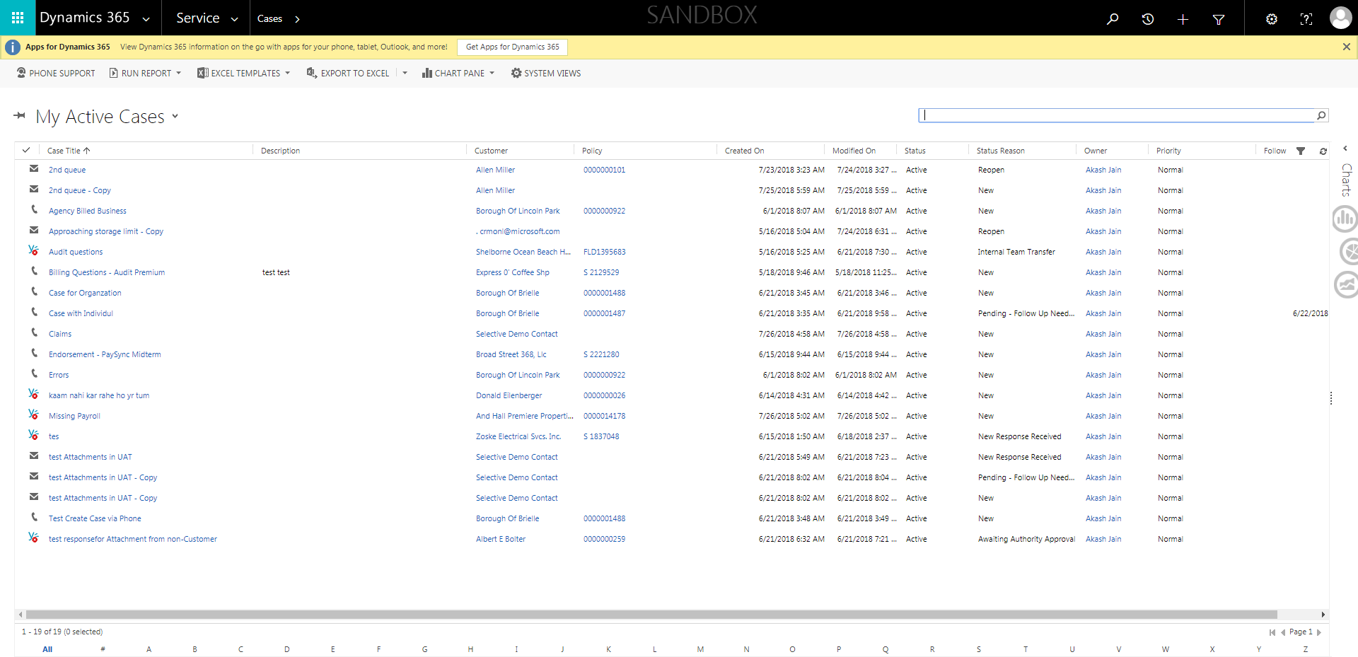

CaseManagement_Copying Case_Instance32_26-Jul-2018_08-24-29_AM_Copycase.png

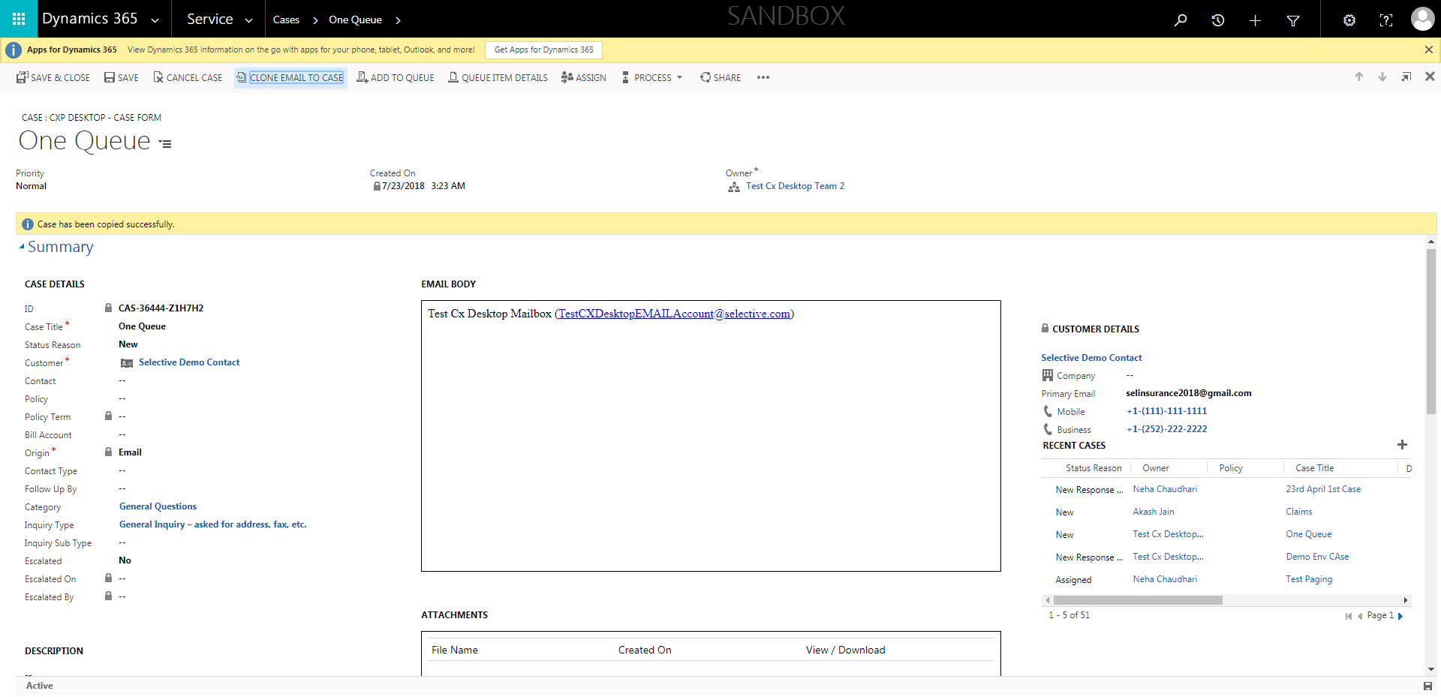

CaseManagement_Copying Case_Instance32_26-Jul-2018_08-24-32_AM_ValidatingCaseentitynavigation.png

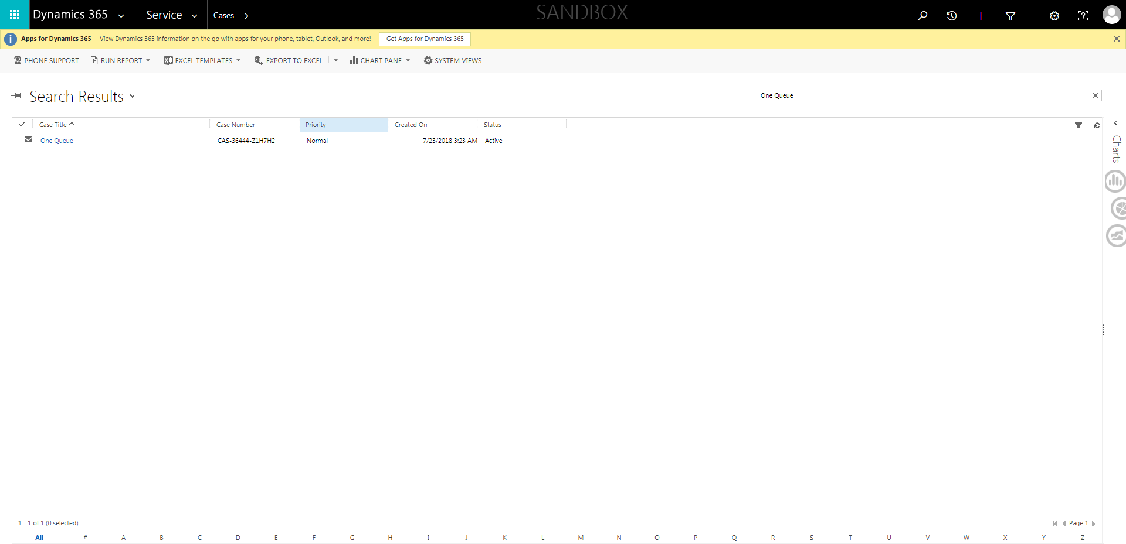

CaseManagement_Copying Case_Instance32_26-Jul-2018_08-24-37_AM_CopycaseVerifyOwner.png



CaseManagement_Copying Case_Instance32_26-Jul-2018_08-22-22_AM_MouseClickActiononStaleElement.png

